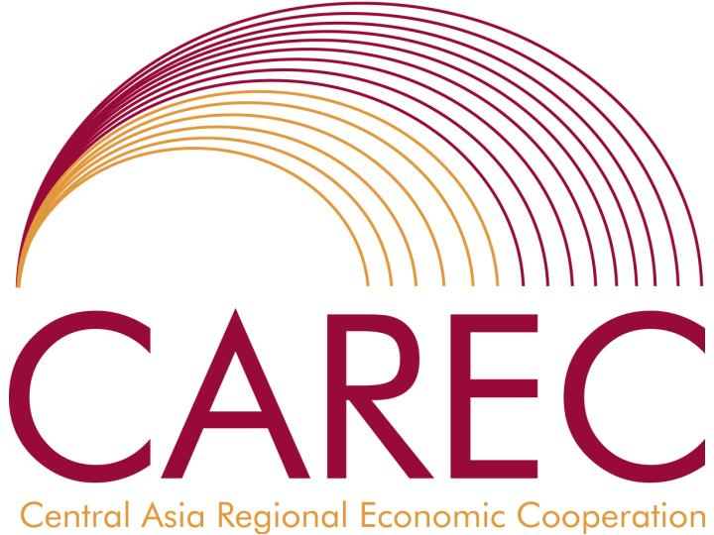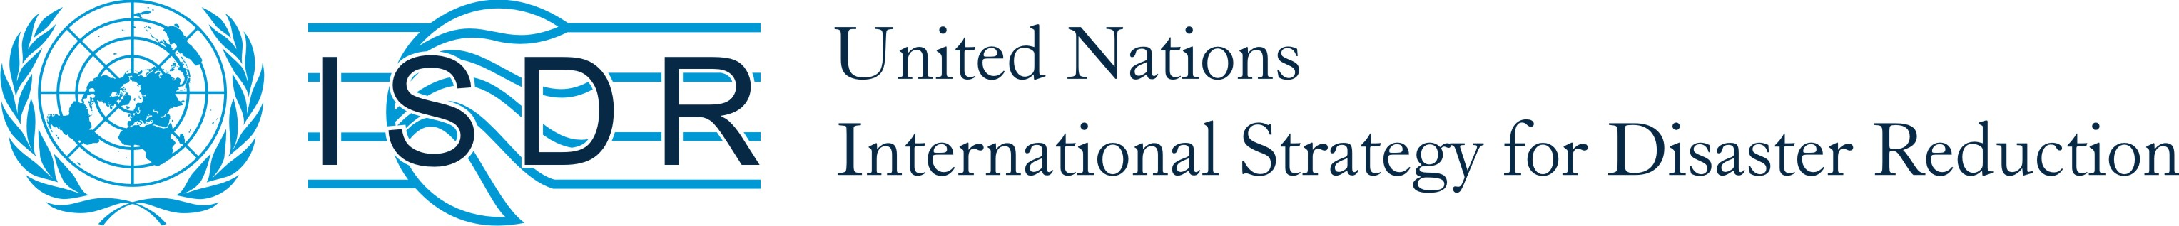

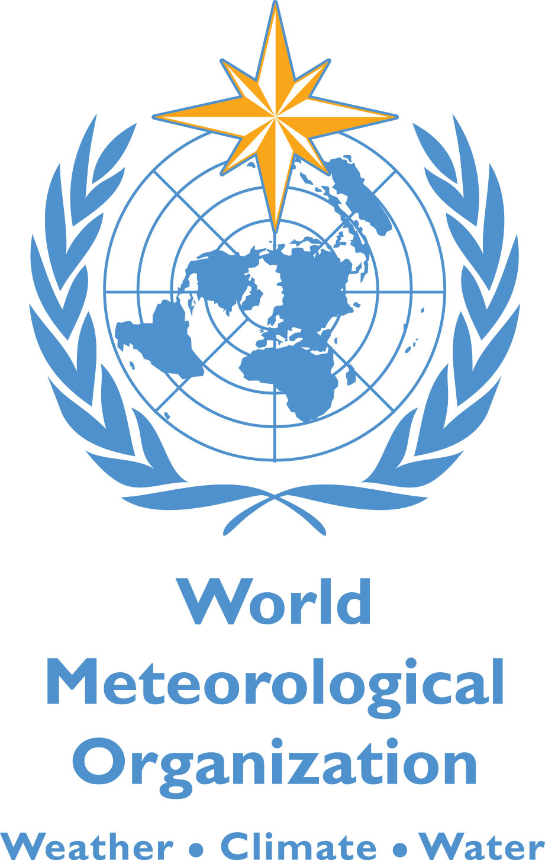

Subject: Proposed Workshop on the Improvement of Weather, Climate and Hydrological Service Delivery in Central Asia

Dear Sir/Madam,

It is our great pleasure to invite you to the proposed Workshop on the Improvement of Weather, Climate and Hydrological Service Delivery in Central Asia, scheduled for November 10-12 2009 in Tashkent, Uzbekistan. The Workshop is part of the Central Asia and Caucasus Disaster Risk Management Initiative (CAC DRMI) implemented in five countries of Central Asia (Kazakhstan, Kyrgyzstan, Tajikistan, Turkmenistan, and Uzbekistan) as well as for Armenia, Azerbaijan, and Georgia. This Initiative is jointly coordinated by the World Bank, the World Meteorological Organization (WMO), and the United Nations International Strategy for Disaster Reduction (UNISDR) secretariat, under the umbrella of the Central Asia Regional Economic Cooperation (CAREC), with financial and technical support from the Global Facility for Disaster Risk Reduction (GFDRR) and international partners.

The main objective of the Workshop is to discuss main issues of weather, climate and hydrological service delivery in Central Asia and reach agreement on how to improve these services by bringing together representatives of NMHS in the region, main users and donor community). It is expected that a scope, main activities and cooperation modalities for regional Hydromet program will be discussed and, possibly, agreed upon during the Workshop.

Participants. Participants will include representatives of:
- NMHS main users: Government officials, weather dependant sectors (early warning and disaster reduction, agriculture, water resources management, energy, transport, municipal services), mass media, etc.
- Senior NMHS officials from Kazakhstan, Kyrgyzstan, Tajikistan, Turkmenistan and Uzbekistan
- Donor, IFI and UN representatives (China and Russia NMHS may also participate)
- Academia, consultants, NGOs,
Number of participants may be in the range 40-60 including at least 4-5 invited participants from each participating country.
Expected results of the Workshop include the following:

1. Broad agreement on main elements of regional cooperation and program to strengthen Hydromet services

2. Better coordinated national and bilateral programs

3. Regional cooperation arrangements between NMHS and donors

4. National and donor commitments towards the regional program

We would like to kindly ask your consent regarding the organization of the proposed workshop in Tashkent on the agreed dates and request your assistance in organizational issues.

Please, let us know if you have any questions. We avail ourselves of this opportunity to ensure you of our highest consideration.

Sincerely,

