Sessions 5 & 6: Simulation: Emergency in “Cano Limpio”

Notes for the Trainer:

Session objectives:

At the end of this session you will:
Understand the need for thorough assessment and analysis of the assessment findings to develop appropriate and effective education programmes.
Understand that using the standards and indicators will prevent or minimise problems in the future.
Be able to analyse the situation so as to be able to formulate an effective response strategy.

Exercise 5.1: Assessing the educational needs of the displaced in and from Cano Limpio
For the next session, you will take part in an assessment exercise. Read the background note below and the individual role guide that your session facilitator will give you. After the simulation, there will be a plenary session where key assessment findings will be shared. Be prepared!

Background Note: Educational Response for the displaced

Rain and Flooding in the Region of Cano Limpio

In 2005, due to the El Nino phenomenon, a period of strong rains destroyed entire regions of the continent. The agricultural region of Cano Limpio, was severely affected by the flooding caused by such rains. The inhabitants are mainly agricultural workers who live as tenant farmers on the farms in these regions. A total of 5,000 families have been left with no livelihood, and it is estimated that the destruction of local school buildings (approximately 30, including the only secondary school in the region) has affected 15,000 children that attended the last trimester of their school year.

The schools that remained in good condition were used as temporary shelters, although the majority of the population had to be evacuated to municipalities of Cano Alto. Much of the population lost equipment and other property and fled the region without documentation. More than 50 people- the majority of them children and elders were unable to flee the water and have died or have been named “disappeared.” These circumstances have provoked a generalized state of crisis.

Adding to this negative environment is the fact that classes in Cano Limpio have been suspended due to the fact that the schools are being used as shelters, thereby increasing the impact of the emergency on the student population. In the affected zone, the schools have been left without students, the teachers have been dismissed and a percentage of them were also affected and evacuated, and were not received as educators in the reception centers. Moreover, the national authorities have placed part of the affected population in shelter centers that are far from their homes; therefore much of the population has mobilized itself to the homes of relatives and family members outside of the affected zone.

The majority of the population that was evacuated to the municipalities of Cano Alto and the children of Cano Limpio have not felt comfortable in the reception centers of Cano Alto, as they have been discriminated against for their rural origin. For instance, some cannot enter the school due to a lack of documentation and moreover, the students from Cano Limpio are blamed by the residents of Cano Alto for crowding their schools and taking up their materials. Furthermore, the displaced from Cano Limpio have been affected by the losses and the emotional experience of the flooding. There are few feeding resources in the reception centers and the level of violence within the family has grown.

After four months, the Ministry of Education has stated that the schools of Cano Limpio will continue to function as shelters until the people can return to their land to work and earn a livelihood.

Space for your notes

Exercise 6.1: Planning /designing the education programme in Cano Limpio and Cano Alto.

Instructions: Based on the results of your assessment and analysis, your group should develop a draft Education Plan for the displaced in Cano Limpio and Cano Alto. Your plan must address the following questions:

- What educational activities/programmes are you recommending and why?

- Which standards and indicators do these programmes/activities address and how do they incorporate cross-cutting issues such as gender, HIV/AIDS, people with disabilities?

- What other information do you need in order to design your education programme or plan your response strategies?

- For any activity/programme that you are recommending that was not explicitly identified as a priority by the community, what steps will you take in order to implement it?

- What steps will you take to make sure that your plan “progressively responds to the educational needs” of the displaced?

Write the key points of your plan on flipchart paper.
TRAINING GUIDE
Sessions 5 & 6– Simulation: Emergency in Cano Limpio

Trainers’ Notes

Learning objectives

At the end of this session participants will be able to:
- Understand the need for thorough assessment and analysis of the assessment findings to develop appropriate and effective education programmes.
- Be able to analyse the situation so as to be able to formulate an effective response strategy.

Main messages
- Response strategies should be based on extensive consultation with the community, including children,adolescents and young people.
- When financial resources are limited, effective educational responses can only be designed by working with communities to prioritise how human and financial resources are used.
- Response strategies should be based on both assessment and analysis of data which have been disaggregated to show differences by age, gender and ethnic group. Ongoing assessment and analysis are also essential.

Timing:  220 minutes (including a 20 minute break)

Method: Simulation exercise

Resources needed: Laptop / data (or overhead) projector / screen / flipcharts and pens/tape or blu-tack (sticky) / role guides for the simulation / name tags for the simulation

Visual aid: PowerPoint slides

In advance of this session:
- Review the materials listed above carefully.
- Adapt them to meet the needs of your audience. You may need to give some guidance to the two teams (assessment team and community) to allow preparation time to be spent constructively and to fully gain from the assessment simulation.
- Review the PowerPoint slides for this session and become familiar with their use.
- Make copies of the simulation roles (found at the end of this trainer’s note) to distribute to participants. You may also want to assign people different roles the night before to speed up the initial part of the session. If you do this, you can also create four or five mixed groups for the analysis and planning part of the exercise. These mixed groups should each contain one or more people who conducted the assessments in addition to a variety of community or government roles.
- There are 18 roles in the simulation. You will need to assign multiple people to certain roles. Before the session begins, make sure that you are prepared for this.
- If there is enough space, it is desirable to locate different groups in different rooms for the role preparation and preparation of assessment findings. For example, the UN agencies and international NGOs may be located in one room or at least near each other in a large room. If possible, the community members and possibly the local NGO should be located in a separate room.
- The gallery walk presentation in activity 5 is most effectively done with a ‘guide’ from each of the groups to present the plan to the other groups, explaining the plan and answering questions that may arise.
- It may be necessary for you to remind participants at the outset of each session whether they are ‘in-role’ or ‘out of role’:
  - Section 1: out of role
  - Section 2: in role
  - Section 3: out of role
  - Section 4: out of role
  - Section 5: out of role
  - Section 6: both in and out of role

Session Overview
Minutes | Activity
15 | 1: Introduction
60 | 2: Preparation for and conducting an initial assessment
55 | 3: Preparation of and sharing of assessment findings
45 | 4: Planning/designing the education programme
30 | 5: Review of the education plans
15 | 6: Debriefing the process and conclusions: assessment, analysis and response planning
220 | TOTAL TIME (20 minute break in between activities 3 and 4)

1: Introduction
15 minutes
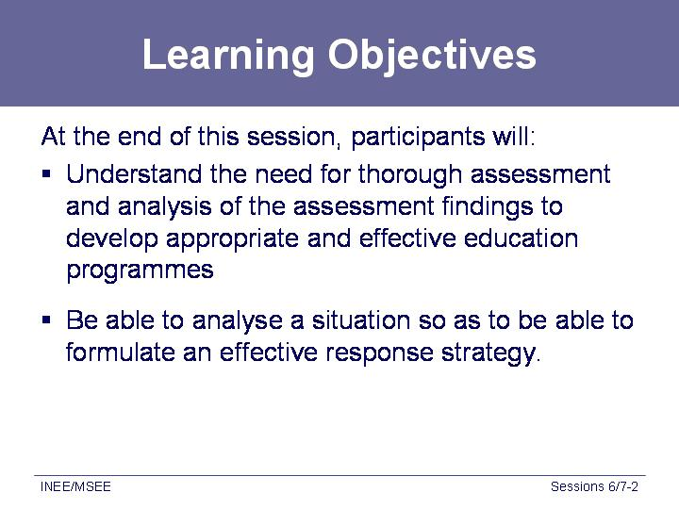 | - Review the learning objectives for the next two sessions.  - Explain that participants will be taking part in a simulation where they will be responsible for assessing an emergency situation and then analysing the assessment findings in order to plan an educational response.  - The simulation consists of 18 different roles that include community leaders, parents, youth, and representatives from the host country government, UN agencies and international and local NGOs.  - The objective of the exercise is for the participants to conduct an initial assessment to find out the educational needs/ priorities of the displaced in Cano Limpio and Cano Alto in order to design an educational response.
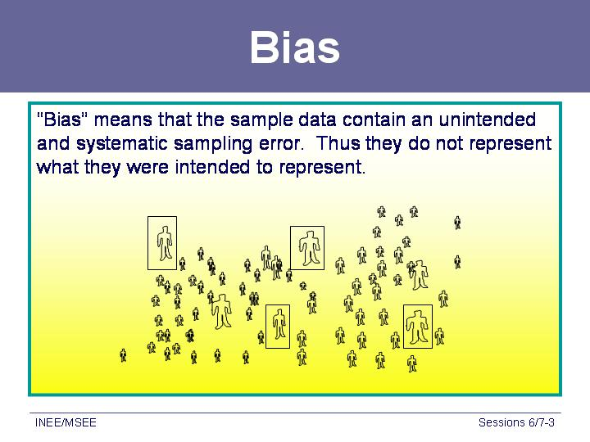  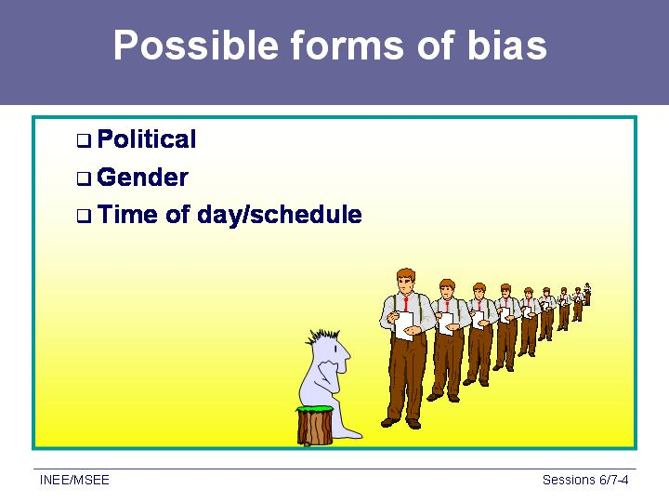  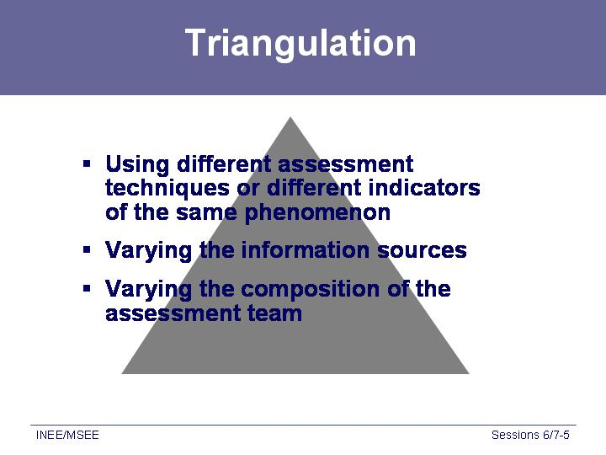 | - Refer participants to page 21 of the INEE Minimum Standards Handbook for Analysis standard 1: Initial Assessment. Give them a few minutes to read the entire standard/ indicators/ guidance notes, and afterwards draw their attention in particular to the first indicator “An initial rapid education assessment is undertaken as soon as possible, taking into account security and safety” and guidance notes 1-4.  - Use the overheads to illustrate some of the key concepts from the guidance notes.  - Bias, for example, is a critical concept to keep in mind when conducting an assessment. Ask participants, what is bias? Take a few answers from the group and then show the overhead. Stress that by varying our methods (observation, interviews, etc.) and by talking to people who represent many different segments of the population (men, women, children, youth, authorities, UN personnel, etc.), we hope to minimise the bias in our results.  - Show the next overhead and ask participants if they can think of potential forms of bias that they may encounter when conducting an assessment. As participants suggest response, stress ways of avoiding these types of bias. For example, if participants suggest gender bias, note that ways of avoiding this type of bias include having women on the assessment team and making sure that assessors talk to both men and women.  - Finally note that the concept of “triangulation” is particularly important for minimising bias. This concept means that we try to vary our information gathering techniques (direct observation, individual interviews, focus group interviews), our information sources (men, women, children, youth, other agencies, secondary data), and the composition of our teams (men and women, representatives from different organisations or different sectors) in order to minimise bias in our results.  - Stress the importance of coordinating assessment teams and results not only for minimising bias but also for minimising the impact on the affected population, who may be suffering from “assessment fatigue.”  - Remind participants that different skills, techniques and approaches are needed to consult with children of different age groups. It may be best to discuss issues separately from teachers and parents but it is important to get parents’/ guardians’ permission to consult with children.

2: Preparation for and conducting an initial assessment
60 minutes (approximately 5 minutes instruction, 25 minutes group preparation, 30 minutes assessment)

Corresponds to Workbook exercise 51, pages 41 – 42 in the Workbook

UPDATE POWERPOINTS WITH CANO LIMPIO SCENARIO
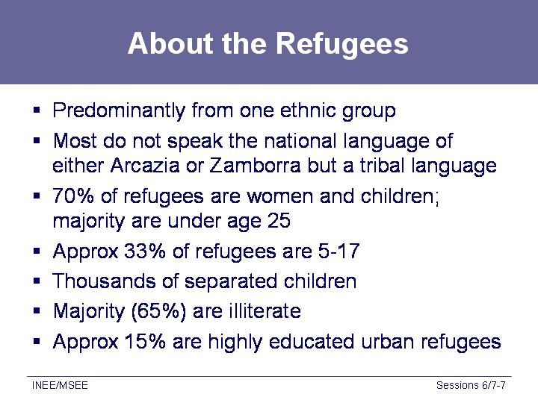  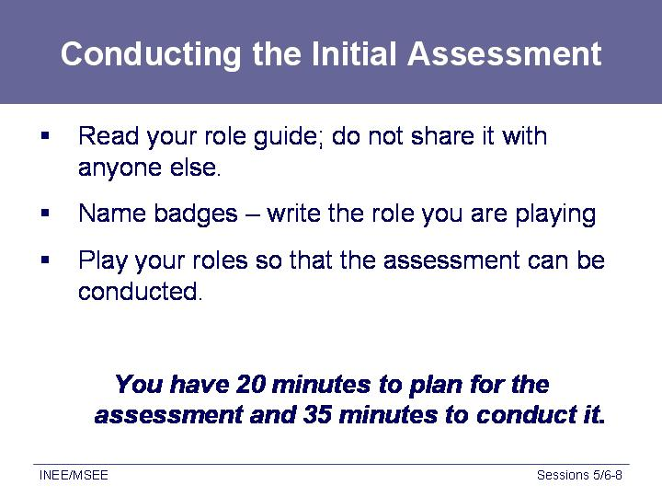 | - Ask participants to read the Background Note “Educational Response for the displaced in Cano Limpio in their workbooks.  - Briefly review the situation in Cano Limpio by showing the relevant PowerPoint slides or overhead transparencies.  - Tell them they have 20 minutes to prepare for this simulation and then 35 minutes to assess the educational needs in Cano Limpio and Cano Alto.  - Distribute the role guides to participants and give them five minutes to review their roles.  - Stress that one of the key activities in initial assessment is actually collecting information from the field, which will require the assessment team to go to the affected community.  - Explain to the assessment mission group (after the other group has left the room) that they are conducting a joint assessment and that they have 20 minutes to develop their strategy for conducting the assessment. They should refer to Analysis Standard 1: Initial Assessment and the accompanying indicators and guidance notes, as well as the Analysis Appendices (INEE Minimum Standards handbook pages 29-38) while developing this strategy, which should include deciding upon groups they will meet with and interviews they will conduct. The mission leader is identified in the role guide.  - As participants conduct the assessment, circulate to observe the process. Make note of efforts to engage community members and government representatives. Be prepared to comment on these during the debriefing at the end of the session.

3: Preparation and sharing of assessment findings
55 minutes (approximately 30 minutes preparing assessment findings, 25 minutes discussion and conclusion)
- The assessment mission group meet and develop their assessment findings. Refer them again to the Analysis Standard 1: Initial Assessment, and accompanying indicators and guidance notes, for a framework for their findings. These should be in dot point format on flip charts.
- The remainder of the participants work in two or three small groups. Explain that these participants are no longer in their roles. They are to brainstorm and list on flipcharts what they think the assessment findings will be given the meetings and discussions in which they have just participated.
- Bring the participants back together and ask a representative from each group to share the assessment findings. Note where there is overlap.
- Tell participants that after the break, they will be analysing and using their assessment findings to develop a plan for their initial educational response.
- Give participants a 15-20 minute break at this point.

4: Planning/designing the education programme in Cano Limpio and Cano Alto
45 minutes

Corresponds to Workbook exercise 6.2, pages 43-44 in the Workbook
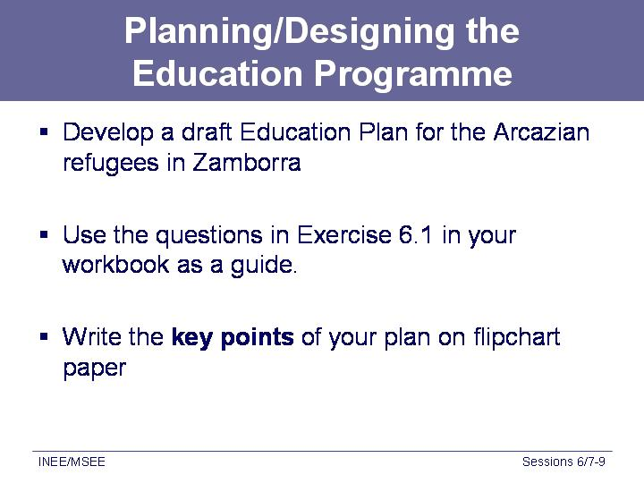 | - Divide participants into four or five small groups. Make sure that you have a somewhat equal representation of roles in each of the groups (e.g. four or five community members in each small group plus some representation of UN, INGO and government). If multiple people played the same role during the assessment exercise, make sure that they are in different groups.  - During this part of the session, participants will work in their small groups to plan/design an education programme for the affected population of Cano Limpio and/or Cano Alto. (change on powerpoint slide from Zamborra to Cano Limpio). They should use all of the assessment findings that were noted during the previous part of the session, the information from the background reading plus any information they have based on the roles they were playing during the simulation. Tell them to use the INEE Minimum Standards handbook in this process, particularly referring them to Analysis Standard 2: Response Strategy (handbook pages 23-25), and accompanying indicators and guidance notes, in developing this plan.  - Their plan should answer the following questions:  - What educational activities/programmes are you recommending and why?  - Which standards and indicators do these programmes/activities address and how do they incorporate cross-cutting issues such as gender, HIV/AIDS, people with disabilities?  - What other information do you need in order to design your education programme or plan your response strategies?  - For any activity/programme that you are recommending that was not explicitly identified as a priority by the community, what steps will you take in order to implement it?  - What steps will you take to make sure that your plan “progressively responds” to the educational needs of the affected population of Cano Limpio?  - Each group should appoint:  - a facilitator whose job it is to make sure that everyone in the group participates and who is responsible for making sure that the group develops their plan and answers all the questions within 40 minutes  - a recorder/note-taker who will record the group’s plan on a flip chart.  - Give the groups 40 minutes to develop their plans.  - Circulate among the groups as they work in order to answer any questions and to take note of how the various groups decided on their priorities.

5: Presentation of the education plans
30 minutes
Gallery walk with guide from each group explaining the plan and answering questions from the other groups | - During this part of the session, participants will be conducting a “gallery walk.” Each group should appoint two guides who will be available to answer questions. For the first 10 minutes of the gallery walk, one of the guides should be available for questions about their group’s plan while the other guide reviews the plans of the other groups. After 10 minutes the guides should trade responsibilities so that both are able to review the other group’s plans.  - Ask participants to walk around the room and review the plans of the other groups. They should ask questions of the guides and try to make note of how the various groups’ plans are similar or different. Give them approximately 20 minutes to review all of the plans.  - After 20 minutes, call the plenary back together.  - Facilitate a discussion on the various plans that is focused on the following questions [You have 20 minutes]:  - Were there any recommended activities/programmes that did not match the priorities of those affected in Cano Limpio? If so:  - Ask the groups how they planned to implement those activities/programmes?  - Do they see any obstacles to implementing them, if the community does not support them?  - What steps would they take to enlist the support of the community?  - Ask the groups to be as specific as possible.  - How did the groups incorporate cross-cutting issues such as gender equity, HIV/AIDS education or landmine awareness education into their plans?  - On what basis did they incorporate these issues (that is, based on which assessment findings)?  - If they did not incorporate these issues, why not?  - If the groups say that they did not focus on the cross cutting issues because they were not raised by the community during the assessment, ask what further information they might want to collect in order to find out more about these cross cutting issues?  - How did the groups incorporate the INEE Minimum Standards into their plans? Take one or two examples from each group. Ask the groups to give different examples and not repeat what another group has already said.  - Is anything left out of the plans?  - Finally, ask how the plans “progressively respond” to the educational needs of those affected in Cano Limpio and Cano Alto? What steps did they include in their plans to address this indicator?  - Stress that this requires ongoing assessment, analysis and monitoring to determine if/when educational priorities change.

6: Debriefing the process and conclusions: assessment, analysis and planning
15 minutes
- After reviewing the plans, ask participants to reflect on the assessment, analysis and planning processes that they have undertaken during these two sessions. Ask questions such as the following:
- For the people who played the roles of the various community members ask:
  - Were their priorities taken into account in the final plans?
  - Did they feel that they were listened to and their views were taken into account?
  - How much information did they divulge when assessors came to talk to them?
  - How much did they push their own priorities?
  - Do they have any other observations about how the assessment was conducted (e.g. no one talked to them, people did not want to hear their priorities but came only with an agenda of their own, or multiple people from multiple organisations asked them the same questions over and over)?
- For those who conducted the assessment (UN, NGO (international and local), host government representatives and donors):
  - What was difficult about the assessment process?
  - What obstacles did you encounter?
  - What would you do differently if you had a chance to do the assessment again?
  - Is there other information that you would have wanted to collect?
- Ask the groups to look critically at their plans, how much do they relate to “what we typically do in emergencies” or to organisational biases (such as we only do primary education or we do not support secondary education) vs. identified needs and priorities from the assessment findings and subsequent analyses?
- Ask what can be done when there is not funding for the priorities that the community identifies? Note that educational plans should consider both human and financial resources and that community participation is essential in prioritising their involvement in areas where there is limited or no funding. The community must understand the limitations that exist and have a voice in determining priorities based on these limitations.
- Conclude by noting that when community priorities are not addressed within education plans, programmes are less effective. For example; parents do not enrol their children (or at least some of their children) in educational activities, young people drop out as they do not see the relevance of the education activities.
- Stress again that assessment and analysis must be ongoing so that education programme managers can design and redesign programmes that progressively respond to the needs of the affected populations.
- Note that incorporating the standards and indicators into education plans in the early stages of an emergency will prevent or minimise problems in the future.

Simulation Roles for the community
Make a photo copy of these pages and cut out the individual roles in advance so they can be distributed. Each person should receive only one role.

Community Leader
You have been a leader for a long time and have a lot of power. The international agencies who have come to help do not want to listen to you and you think that they want to choose new leaders. They want to talk to people in your community without going through you and do not give you the respect you deserve. You believe that the most urgent need is to recover the animals and lands lost in the flood. You are in agreement with the use of local schools as hostels and shelters.

Women’s group community leader
You represent a large group of women whom, like the better part of the population, have suffered many material losses. What you want is for the community organizations to recognize your group and for male leaders to not exclude the decisions made by women, and to understand the problems that affect women and children. You believe that if there were women’s literacy classes and intensive training for women to become teachers, women and girls would be more empowered.

Religious Leader
You really believe that when a society is fragmented in moments of crisis, the religious teachings are the only anchor that people have. It would be a good investment for the international and local NGOs to fund you so that you have a building that can be a focus and gathering point for the community. From here, you can try to console the population and to teach the children to have confidence in the will of God and to obey the laws of your religion and culture. This would help to heal the community. You think that the school puts too much emphasis in academic themes and that schools are forgetting about religious teaching.

The following roles may be distributed to multiple people.

Community member # 1
You were an owner of a local commercial phone company in your community, and unlike most of your neighbors, you have not suffered as many losses. You want to argue for an education programme that will build the young people of your community and enable them to face whatever the future may hold. You know that many people will not want girls to go to school but you know that developed countries are those where boys and girls are educated equally and given the same opportunities.

Youth # 1
You are a secondary school student. The flood destroyed the only secondary school in the province. While there has been lots of talk about education, nobody seems to care about you and your friends who were part way through secondary school and who are now left with no future and no means of securing the education you worked so hard for. Secondary school is a priority for you and your friends. You want to be a doctor when you leave school; you do not want to learn shoemaking or masonry and have no intention of becoming a farmer like your father and your uncles.

Parent/Mother of Family # 1
You have four children of primary school age. You know of many, many parents who also have primary school aged children. Your neighbours have a child who is physically handicapped and cannot go to school unless they can get a wheelchair. You are also concerned about the proposed site for the school that will be the closest to you. In order for your children to get there, they will have to go through an area where a lot of single young men are living. You are not sure if you will allow your elder daughter to attend the school because it could be unsafe to let her walk through this area.

Community member # 2
You believe that education is important for all children. You have never been a teacher, but when you were younger that was your dream. You understand how children learn and, when you were in school, the teachers often said that you would make a good teacher and tried to encourage you. Unfortunately, you do not have the qualifications necessary to be a teacher as you have not completed secondary school. In fact, you only have a primary education. Many of your friends are in the same position and you know that some of them would also like to become teachers. Maybe now you and your friends will have a chance to become teachers, in order to help the children affected by the flooding.

Parent/Mother of Family # 2
You have three children, one of whom finished primary school just before the flood. The other two should be in grades 2 and 4. You think education is important and you want all your children to finish school. Your daughters will make better wives and mothers if they are educated and your son will have opportunities that you have only dreamed of. Before the flood, you worked very hard to earn the money for school fees for all your children but with the flood, many crops have been lost, there are no jobs, and you are worried that your children may not be able to go to school. Given your situation, you believe that the educational authorities or the international cooperation agencies could offer educational materials for all of your children. You are also concerned that if the authorities choose a curriculum that is different from what your children were studying, they will not be able to adapt to their new situation. It would be much better if they continued with the previous curriculum so that they can continue with their studies once the effects of the flooding have passed and they may return to their daily lives.

Youth # 2
Although the flooding had very harmful effects, now that you are living in a different region, it may be possible for you to continue your studies in another school. You had to drop out of school at grade 3 because your school was destroyed by the flood and you had to collaborate with your mother and father to help them find work and to take care of your younger brothers and sisters. There is still a lot of work that has to be done every day including collecting firewood and water, but you really want to go to school and finish third grade. You know it will not be easy but you are sure that they must be able to teach you something that will be useful for you as an adult.

Girl
You are 8 years old, but because of the discrimination you face as a girl, you still cannot read or write properly. It is not fair that you cannot go to school because you have to help out at home. Your brother went to school before the flood and now that classes are interrupted, he helps out very little at home. You don’t want to grow up without an education. It should be possible to at least learn to read and write before it is too late; therefore it is your desire that at year’s end, they finish the reconstruction of the school and you can begin to learn to read and to write.

Woman
You cannot read or write but you are not stupid and it is hard to be treated as if you are stupid. You would like to see a new women’s group formed to help you and women like you to learn skills that will help you earn a living and perhaps one that would organise women for child care groups. You would also like to learn to read and write so that you cannot be cheated in the market or by other women who say that they speak for you. You don’t trust the current leaders due to the fact that during the flood, the humanitarian help that was given by the government and through international cooperation to women’s groups seemed to be inequally distributed between affected families and no one presented a report about this help.

Boy
Your parents have both died of AIDS so now you live with your aunt and uncle. Because you are only 10 and you were affected by the flood, sometimes it is really hard to know that there is no one who loves you and cares for you. Sure your aunt and uncle give you food but caring for you is not just about that, it is also caring about how you feel. Everybody avoids you because you are HIV positive and there is nobody who will play with you. People call you names and laugh at you. All you want is to be treated the same as other people your age. Even though you are sometimes really tired, it would be good to have friends and be able to play together. There must be somebody who cares what happens to you!

Teacher # 1

Due to the fact that the school in which you worked has been transformed into a shelter, you already have gone four months without carrying out any teaching activities, and thus, have not received your respective salary, as the local authorities have adjucated that in these moments, there are other, more pressing priorities that must be addressed for the affected population. You have offered to support the shelter that functions in the school in which you worked before, but the international institution in charge of the shelter’s functioning underestimates your potential and credentials to your lack of experience working with shelter populations. At this time, you are already evaluating the possibility of returning to your city of origin; outside of the region affected by disaster.

Teacher # 2

You work in one of the schools located nearby the affected flood region and because these schools have not yet been used for shelter, the student population from other educational centers have been referred to your school. Your school is facing a set of situations such as: many children are not coming with documents, thus making it hard for them to be registered in school, there is a lack of space and materials for new students, as well as a lack of educational support. The school feeding program is not sufficient for all of the children that currently attend the school.

Simulation Roles for the assessment mission
Make a photo copy of these pages and cut out the individual roles in advance so they can be distributed. These should be on different coloured paper to the first group. Each person should receive only one role.

UN Agency
You have been designated the lead actor for education for this emergency. Therefore you are leading this joint assessment mission. The focus falls on the attendance in primary education and because of limited funding there will be almost no money for anything else. You really need other agencies and organisations to help fund education programmes. Your agency has a policy of not paying teachers’ salaries, nor school fees.

Government Representative from the Affected Zone

The impact of the disaster on the region, and the deaths and destruction that resulted, exceeds the capacity of the local government. The government has very little money and the education for its own population is very limited. The government has given permission for the schools and other public buildings that have not been affected by the flood, to serve as shelters for the affected population, but all of the responsibility of operating these shelters falls on your shoulders, as well as securing basic services for the population (healthcare, water, sanitation, etc). If you had to set up a program for education in emergencies, it would be the regular program of education of your country, which should be reestablished as quickly as possible. This would allow professors to return to their teaching activities and therefore, they would once again receive their daily salaries, and as the international financial institutions pay their salaries, this would save the ministry large sums of money, as well as the necessity of introducing more trained teachers to the district.

UN Agency # 2
Your agency is not the lead actor in education for this emergency, but it has a very strong policy of supporting education and using these types of situations as an opportunity to upgrade education programmes by reincorporating children, especially girls, into the education system, as many of the children have broken ties with the school. In similar situations, you have introduced several programmes such as environment programmes, health education and hygiene promotion, psychosocial support, HIV/AIDS education and life skills education. You feel very strongly that these programmes are necessary for the students, especially those that still find themselves in shelters. You know that there is never going to be a secondary education programme because neither your agency nor the lead agency has a policy of supporting it. You think that vocational training, including basic literacy and numeracy skills, is the answer for the adolescents and youth who cannot be accommodated in the primary schools but who can participate in the rehabilitation and reconstruction of schools and their community.

International NGO # 1: Emergency Response Team member
A donor from your country has given you funds to implement an education programme. You know exactly what needs to be done as you have been conducting education programmes in the neighbouring countries for years. However, before you start your program you need the approval from the Ministry of Education. You also need other agencies to rehabilitate or reconstruct the affected schools or if that is lacking, you need funds to reconstruct/rehabilitate schools on your own.
You have no special education programme that responds to the particular education needs of children affected and displaced by disasters. However, as you believe that they are a very small percentage of the current caseload, you think it would be better to just start with what you have and worry about the others later.

International NGO # 2: Rapid Emergency Response Team member
You have been working alongside the host country government in education of the affected country and region for a number of years as part of your development programme. You don’t believe that the schools that are being used as shelters will be freed up for education anytime soon. Therefore, it would be most cost effective and appropriate if the school year was suspended temporarily, and an accelerated program was designed for those students who cannot finish the school year successfully. You would like to start an emergency education programme but will need specific funding to get started as all of your current funding comes from donors who are funding development programmes.

Local NGO
You have a particular interest in education and have been supporting education in this country by working with the government for a long time. You would like to expand your programme to the community affected by disaster, but you need funds and infrastructure support to do this. You really believe that because of the disaster and the need for stability and routine in children’s lives, which education can afford, it would be best if educational activities are taken up as quickly as possible, although these activities will happen in alternative physical spaces.

Financial Institution
Your funding priority in terms of education is primary education. There is no money available for pre-school or secondary education. This policy has been decided on the basis that primary education is the greatest need. There is small funding available for creative initiatives but any such funding will be limited to twelve months. It is vital that primary education is established immediately as you need the reporting mechanisms in place to account for the funding spent. At this stage it is better to start something, even if it is not exactly what you would like so that the allocated funding can be spent and next year’s funding assured.

