 |  |  |  |  |  | 
 |  |  | 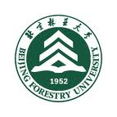 |  |  | 

International Conference on
Responses of Forests and Adaptation Management to Climate Change
8- 10 August, 2011 | Yichun, Heilongjiang, China

Sponsors:
- Chinese Academy of Forestry
- Asia-Pacific Network for Sustainable Forest Management and Rehabilitation (APFNet)
- International Union of Forest Research Organizations (IUFRO)
- USDA Forest Service
- University of British Columbia (UBC)
- Michigan State University
- University of Alberta
- Finnish Forest Research Institute (METLA)
- Chinese Society of Forestry
- Ecological Society of China
- Beijing Forestry University
- Northeast Forestry University
- Institute of Applied Ecology, Chinese Academy of Sciences (CAS)

Organizers:
- Chinese Academy of Forestry (CAF)
- People’s Government of Yichun, Heilongjiang, China

If your organization or program would like to become a sponsor, please contact Ms. CHEN Yujie via email to chenyj@caf.ac.cn.

Key Dates (Deadlines)
Submission of Symposium Proposals December 31, 2010
Call for Abstracts January 1, 2011
Acceptance of Symposium Notified March 1, 2011
Submission of Abstracts May 1, 2011
First Early Bird Registration Closes June 30, 2011 (Registration fee: USD$250)
Second Early Bird Registration Closes July 31, 2011 (Registration fee: USD$300)
Overview of the Conference
The International Conference on Responses of Forests and Adaptation Management to Climate Change will take place on 8-10 August 2011 in Yichun, Heilongjiang, northeast of China. It brings together experts and policy makers from around the world on forest ecology and biology, eco-hydrology, watershed management, forest fires, forest entomology, global change sciences and forest managers to share knowledge and research experiences, and develop scientific adaptive measures for sustainable forest management in a changing environment

- Proposed Program
The Conference will include plenary lectures, parallel symposia & workshops, poster sessions and field trips.

- Language
The official language for the Conference is English.

- Conference Fee
Conference fee will be levied which will cover the cost for registration, conference materials including program and abstract books, local shuttle services between Conference venue and accommodation, meals, coffee breaks and in-conference fieldtrip.
Until 30 June 2011 | Until 31 July 2011 | After 1 August 2011 (incl. on-site registration)
US$250 | US$300 | US$350

- About Yichun City, Heilongjiang Province
Located at Lesser Hsinggan Mountains in the eastern part of Heilongjiang Province, Yichun faces the border of Federal Russia just cross Heilongjiang River. It is known as the Home to Korean Pines and the Home to Dinosaurs. It is accommodated with a variety of tourist items, including the ice and snow sightseeing, wetlands, skiing, bird-watching, drifting, fishing and the tour for taste of the exotic along the border river. All of these items have been well received by the tourists from home and abroad. The participants will have opportunities to experience a wide diversity of cultural and natural landscapes of Northeastern China during the pre-, mid- and post-conference excursions.

The in-conference fieldtrip will be organized and costs will be borne by the Conference. Optional post-conference fieldtrips to nature reserves, wetlands, and other sight-seeing attractions will be organized by travelling agency.

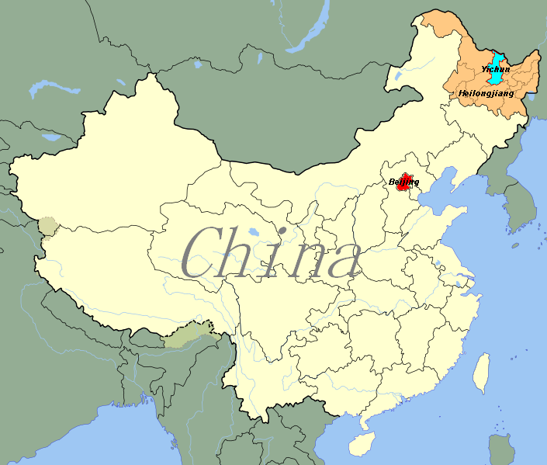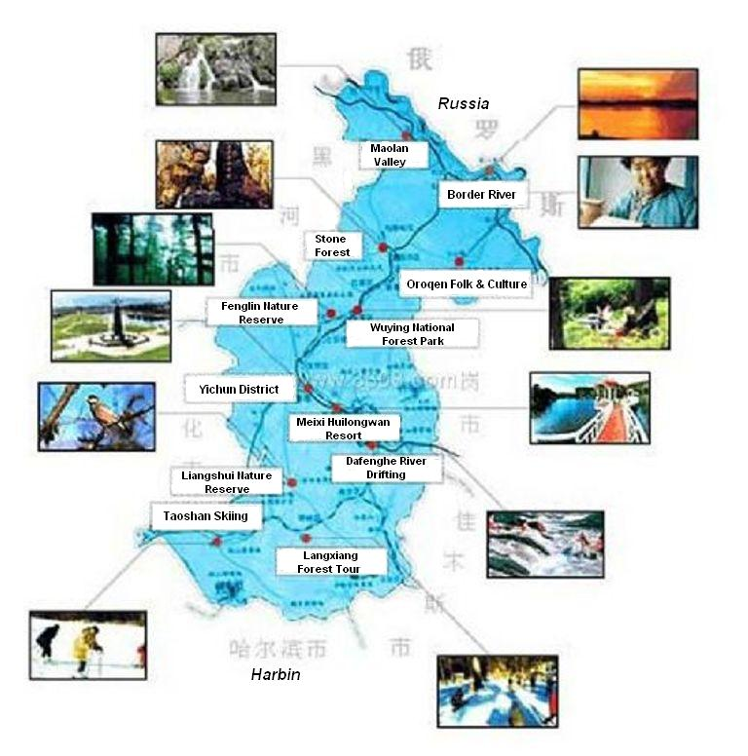
Call for Symposium Proposals

There is no longer any doubt that the earth’s climate system is warming up as is evident from observations of increases in global average air and ocean temperatures, widespread melting of snow and ice and rising global average sea level. Forests, as the product of the soil of the earth, the carbon dioxide and oxygen of the atmosphere and the precipitation, warmth and the light of the climate system, would naturally change as the climate changes. The rate of these changes would depend upon the pace at which the climate is changing as also the natural resilience of the forest ecosystem. The accelerating climate change will reduce adaptation possibilities and thus forests may turn from carbon sinks to net emission sources of carbon in the coming decades. The new imperative is to develop adaptation strategy to manage the capacity of forest to cope with changing climate.

Till date, however, there are still large knowledge gaps in understanding the impacts of climate change on forest productivity, distribution and phenology, on the ecological linkages between the carbon and hydrological cycles in forest ecosystems, on the range and the pace of shifts in biodiversity, on possible impacts on genetic structures of species and its consequences for adaptation, on the disease, pest and fires in forest ecosystems, and on the weakening of resistance against invasive species among many other unknown challenges that the changing climate is likely to bring before the forest managers. The goal of this Conference is to provide a forum for experts and policy makers from around the world on forest ecology and biology, eco-hydrology, watershed management, forest fires, forest entomology, global change sciences and forest managers to share knowledge and research experiences, and develop scientific adaptive measures for sustainable forest management in changing environment.

Potential thematic topics:

- Impacts of climate change on trees and forests
- Forest carbon cycling and carbon accounting
- Integrated carbon and water process
- Coupling carbon and water processes using remote sensing, GIS and modeling
- Managing Forest Pest, Disease and Fire under a Warming Earth
- Adaptive forest management for multiple functions

You are kindly invited to submit a proposal for a symposium to the conference. All presenters are invited by the symposium organizer basically. But the conference organizer has the opportunity to fill in contributed oral presentations into related symposia at blank time slots. The standard time slots are 15 minutes of presentation + 5 minute Q & A.
Requirements and Guidelines
The deadline for symposium proposal submission is December 31, 2010.
SYMPOSIUM DETAILS
Title
Principal Organizer
(Name, affiliation)
Co-organizers (Names, affiliations)
Symposium Overview |  | Background information, goals, objectives, importance and interest to the conference participants, within 200-300 words
Presenters (Names, affiliations and tentative titles) |  | 1.  2.  3.  4.  5.
CONTACT DETAILS
Organizations |  |  | Department
Name |  |  | E-mail
Address
City / State |  |  | Country
Postal Code |  |  | Telephone
Fax |  |  | Website

- Secretariat
For further information, please visit www.forestry.ac.cn.
Dr. WU Shuirong | Dr. SUN Pengsen
Institute of Forestry Policy and Information, CAF | Institute of Forest Ecology, Environment & Protection, CAF
Tel.: +86-10-62888322  Fax: +86-10- 62884836 | Tel.: +86-10- 62889534  Fax: +86-10- 62884972
Email: wu.shuirong@gmail.com | Email: sunpsen@forestry.ac.cn

