Islamic Relief Worldwide

Disaster Preparedness and Capacity Building Specialist

BASE LOCATION: | Birmingham, UK
REPORTING TO: | Head of Humanitarian Department
LINE MANAGEMENT RESPONSIBILITIES: | Project Staff
PURPOSE OF DIVISION:
International Programme Department is:
to contribute to the process of global poverty alleviation and
to strengthen IR global work through the provision of technical support in cooperation with regional desks and support units
JOB PURPOSE:
Manage developing Islamic Relief’s disaster preparedness and response plans and policies
Develop Islamic Relief’s Surge Capacity and Roster to effectively respond to disasters and emergencies
Manage the provision of disaster preparedness and management training to Islamic Relief staff, strategic partners and potential partners and ensure the provision of professional and responsive advice in the field of disaster management
Act as the principal point of reference for Islamic Relief staff in disaster preparedness and disaster risk reduction issues

Position of Disaster Preparedness and Capacity Building Specialist within IR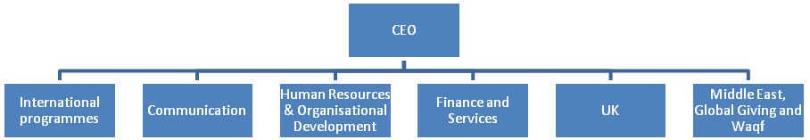

Structure of International ProgrammesDepartment

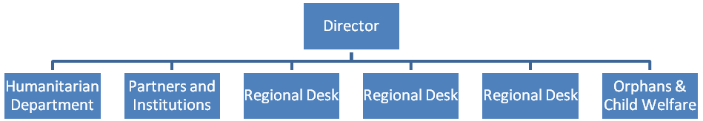

KEY WORKING RELATIONSHIPS

SCOPE AND AUTHORITY
Scope of the Role:

Responsibility for Resources:

KEY ACCOUNTABILITIES
This section should detail the 5/6 key accountabilities against which the job holder will be managed. These should then be broken down into key activities and responsibilities, and start with active verbs as far as possible.

The job holder is accountable for fulfilling his or her roles and responsibilities in line with Islamic values and principles of fairness, humanity, honesty, respect and fair treatment of his/her colleagues and staff..

- Identify priorities for disaster preparedness, mitigation, and disaster risk reduction through assessments of prevailing/ frequent disaster risks, vulnerabilities and capacities.
- Assist Islamic Relief and local partners in developing disaster preparedness capacity building programmes.
- Conduct in-depth analysis of the risks, vulnerabilities and capacities in high risk zones and in high risk communities and develop adequate capacity building programs to address those vulnerabilities.
- Be responsible for the development of training modules for disaster preparedness including the design and preparation of training materials.

- Manage planning, development and organization of Islamic Relief’s surge capacity and roster.
- Manage training needs assessment for staff members involved in emergency response and roster.
- Organise internal and external training events for Islamic Relief staff, local partners and volunteers involved in emergency relief and disaster response and roster.
- Monitor a training-matrix for humanitarian department staff and volunteers to build overall capacity.
- Visit field offices to provide support and training in their emergency preparedness planning.
- Manage the dissemination of “best practices” in the field of disaster preparedness and risk reduction through visits to organisations, private study and attending training courses.
- Write directives advising divisions and department managers of their staff training and development needs and suggest training activities in the field of Disaster Preparedness and Management.
- Network with other training professionals and keep up to date with training materials, publications and courses and with changes and developments in training practices.
- Initiate (in conjunction with the IT dept.) Islamic Relief’s computer and web based learning programme, to provide a flexible service and to promote the learning process within the organisation.

PERSON SPECIFICATION
It is essential that the post holder shows a good understanding and empathy with the Islamic values and principles as well as commitment to IRW’s vision and mission. This section should detail the requirements of the role in the following sections:

Essential:

Knowledge, Skills and Qualifications
- Strong facilitation, coordination skills and representation skills
- Excellent spoken and written English language skills
- Analytical and strategic planning skills
- Proven numeracy and financial management skills
- Adaptable and flexible
- Strong training delivery and presentation skills
- At least a Master degree in disaster
- preparedness or management or international development
Experience
- Theoretical and practical knowledge in establishing and managing emergency operations, including formulation of strategies, plans of action, project proposals, budgets and reports.
- Managerial skills for the development, implementation, and analysis of technical cooperation programs related to capacity building in disaster preparedness and development of surge capacity.
- Demonstrated experience and high level of competence in most of the following fields.
- Advocacy and awareness rising
- Training on disaster management
- Community managed disaster preparedness
- Knowledge on PRA/PLA approaches
- CBO capacity building/training
- Coordination between government departments and CBOs
- Institutional development
- Proven experience of managing a high workload and multiple priorities
- Knowledge of sensitivities and experience of work in humanitarian setting with the national partner organisations, Government, INGOs and UN agencies

Personal Qualities
- Knowledge and experience of working with disaster risk reduction, preparedness and development issues and a good understanding of relevant humanitarian and policy issues.
- A proven track record of effective programme and people management.

Desirable:
- Experience of work in emergency setting
- Knowledge and experience of work with bilateral and multilateral donors

Signed by: __________________________ (Direct Line Manager)

Signed by: __________________________ (Divisional Director)

