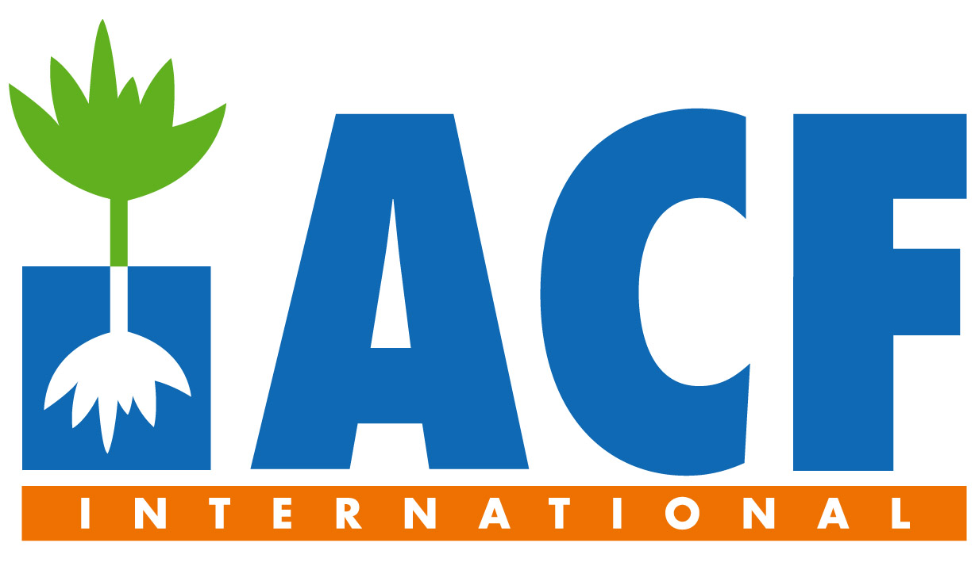

2011, October the 19th
Action Against Hunger (ACF) was founded by a group of prominent French figures in response to the emergency caused by Afghan refugees fleeing to Pakistan to escape fighting in 1979, with the aim of eradicating hunger in a more global, lasting and effective way worldwide. ACF’s mission consists of saving lives via the prevention, detection and treatment of malnutrition, in particular during and following disasters and conflicts. The organisation focuses its activities on an integrated approach, taking various aspects into account: “Nutrition, health and healthcare practices”, “Food security and livelihoods”, “Water, sanitation and hygiene” and “Advocacy and awareness-raising”
In 2009, ACF-International was active in over 40 countries, coming to the aid of around 5 million individuals. By integrating our programmes with regional and national systems, ACF is ensuring that short-term actions are becoming long-term solutions.

We are looking for: A REGIONAL DISASTER RISK MANAGEMENT ADVISOR

Country: New-York and missions (Indonesia, Bangladesh, Pakistan, Afghanistan, Myanmar, Mongolia, India, Nepal…)

Length of Contract: 12 months

General objective: The position will lead capacity building of emergency planning and risk management in identified countries whilst taking a leading role in sector product development and global personnel development/management. The position will represent ACF on the national and regional stages as needed to diverse actors to promote ACF expertise and enhance relationships and opportunity. The position will support Emergency Operations as needed.

Responsibilities:
- Support Emergency Planning at the Mission Level
- Build capacity of Personnel in Risk Management
- Risk Management Sector Development
- Represent ACF at the national and regional level (and where relevant global level) relative to Risk Management (DRR, DRM, DM, etc.)
- Support Emergency Operations

Qualification and previous experience:
Masters’ Degree or equivalent field experience in DRM, Education, Humanities or other applicable degree
Experience in Emergency Planning from Local to National Levels and a significant experience in training design and delivery / Demonstrated Experience in Assessment and Project/Program design
Knowledge of WASH, Nutrition and FSL intervention modalities
Good context analysis and understanding of humanitarian and development agendas
Good capacity to build relations with organisations, donors, individuals, teams and authorities

Status: Employee
- Fixed-term contract, provided by ACF according to the French labour law.
- Total average yearly gross income: from 41160 € to 47160 €
- Food and housing: 1000 € / month average
- Per Diem : 210 € / month average
- Support to the R & R costs : 110 € / month average
- Transportation costs to and from the mission : 460 € / month average
- Monthly gross salary ranging from 1650 € to 2150 € (Net: from 1518 € to 1978 €) depending on relevant experience (possibility to increase up to 2750 € gross (2530 € net) according to seniority and performances)
- 25 days of annual paid leaves
- 20 days of R & R per year
- Social benefits: Medical, life and accident insurance provided by the institution
- Accompanied position (partner, children) according to the place of assignment
- Training before departure and all along the career with Action Contre la Faim.
Please, send your CV and a cover letter to Camille DARDE under the references DRMREG-1011:
recrutementvolontaires@actioncontrelafaim.org

