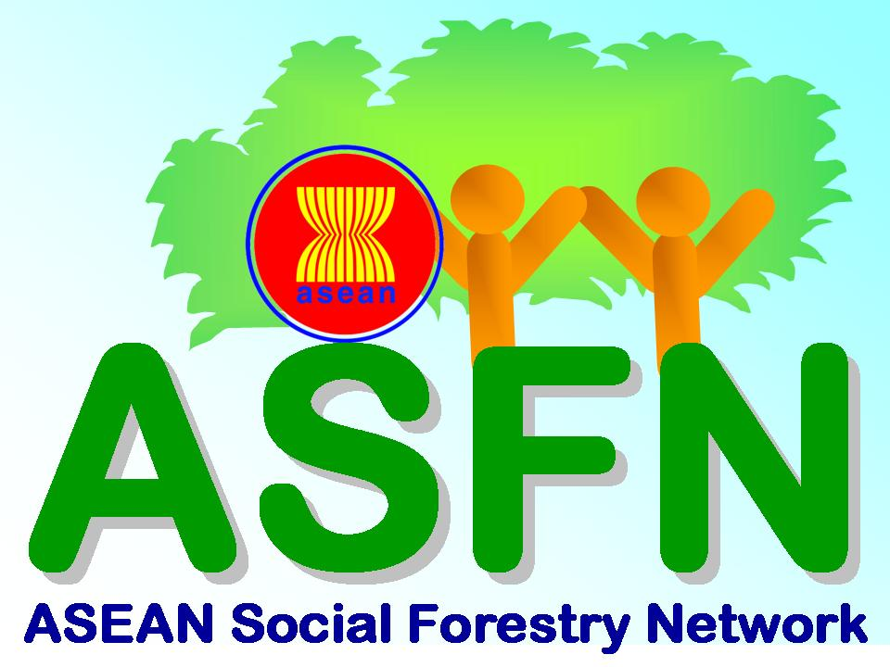
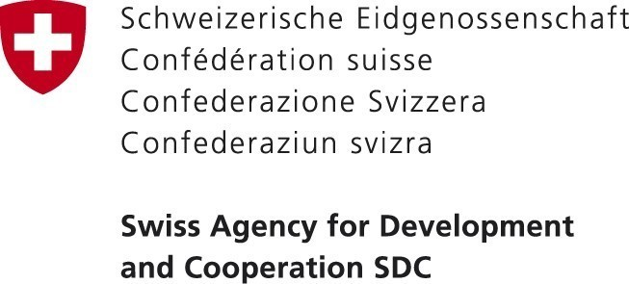


Mitigation & Adaptation: Managing Forest Conflicts in a context of Climate Change
for the ASEAN Region

27 February to 2 March 2012
Siem Reap, Cambodia
DETAILED INFORMATION ON PARTICIPANTS
First Name |  |  | Last Name
Gender |  |  | Date of Birth
Nationality |  |  | Education | BA, BSc,  MSc, MA, PhD
Position
Telephone |  |  | Fax
Permanent Mailing Address

Personal E-mail Address:
DETAILED INFORMATION ON PARTICIPANT’S ORGANIZATION
Office/Organization
Office Address

Telephone |  |  | Fax
Email
Name of Manager/Supervisor
Manager’s contact E-mail
Tel |  |  | Fax
DETAILED INFORMATION ON FUNDING SOURCE
Organization
Contact person
Email
Tel |  |  | Fax

Participants must
- Have at least 7 years of work experience in the public or private sector, or civil society on forestry or natural resource management and climate change policies in the ASEAN region;
- Have a good command of the English language; and
- Be citizens or residents of the ASEAN region or are actively working on forestry or conflict management issues in the ASEAN region.

- What main activities are you currently involved in?

- How many years have you been working on forestry or natural resource management or conflict management issues in the ASEAN region?

- What are your main expectations for this course?

- How did you hear about the course?

Please (√) include the following with your completed application / nomination form:

(√) A short resume (not more than 1 page) containing information of your educational background, work experience and current responsibilities.
(√) Your answers to questions 1 to 4 above.

Please return the completed form and supporting documents by 31 January 2012 to:

Celina Yong
ASEAN Social Forestry Network Project Officer
RECOFTC – The Center for People and Forests
PO Box 1111 Kasetsart Post Office Bangkok 10903, Thailand
Tel: +66 (0)2 940 5700 Ext. 3220 Fax: +66 (0)2 561 4880
E-mail: celina.yong@recoftc.org

The course organizers reserve the right to select the most suitable candidate for the course.

