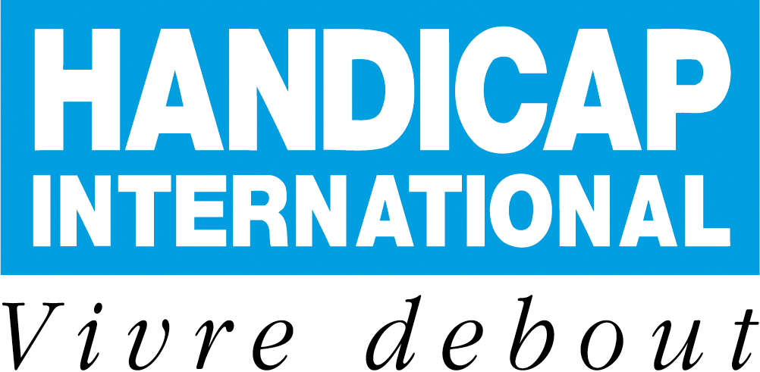

Handicap International is looking for Inclusion Project Manager

COUNTRY : Sri Lanka | CITY : Based in Batticaloa (East)
Starting date : As soon as possible | Length of the assignment : 1 year
Closing date for application : 08/03/12 | Advertisement reference : IncPMSLanka1202

Handicap International is an independent and impartial international aid organisation working in situations of poverty and exclusion, conflict and disaster. Working alongside persons with disabilities and other vulnerable groups, our action and testimony are focused on responding to their essential needs, improving their living conditions and promoting respect for their dignity and their fundamental rights.
Handicap International is a not-for-profit organisation with no religious or political affiliation. It operates as a federation made up of a network of associations that provide it with human and financial resources, manage its projects and implement its actions and social mission.
For more details on the association: http://www.handicap-international.fr/en/s/index.html

JOB CONTEXT:
Handicap International (HI) has been working in Sri Lanka since mid 2004 and it has established itself in Sri Lanka as one of the key organization in disability sector. Handicap International in Sri Lanka develops and implements projects to improve the quality of life of people with disability or injury and their families, in whatever context, promoting their active participation and social inclusion, developing partnerships at all levels, in the frame of the national policy on disability.
Currently, HI Sri Lanka program is comprised of 95 staff (Including 09 international staff) and is spread in three provinces (North, east and central) of Sri Lanka
The eastern base of HI Sri Lanka programme is Batticaloa and is covering the whole of the Eastern area of Sri Lanka. Currently in east HI is implementing a Physical Rehabilitation Project within the Batticaloa Teaching hospital.
On the other hand, HI is implementing a 42-months consortium project titled ‘Socio-economic empowerment of Conflict-affected communities in the Northern and Eastern Provinces of Sri Lanka’ with 2 INGOs and a national NGO. HI main role is to guarantee to mainstreaming disability in all activities.
In addition to above, HI Sri Lanka is part of two South Asia Regional (Multi-country) Project on Physical Rehab (with focus on Community Based Rehab) and Inclusive Disaster Risk Reduction.

JOB DESCRIPTION:
The Consortium project will support inclusive community-based structures to become the focal point of all development activities in the targeted areas of intervention. As such, the infrastructure and livelihood components of the project are interdependent and will allow communities to develop sustainable income generating activities. Similarly, by addressing issues of protection (at a psychosocial and legal level) and of inter- and intra-community conflict, the project will ensure that the target communities develop sufficient social capital to recover and work together towards development. By mainstreaming disability in all components of the project, the project will ensure that the most vulnerable and at-risk segments of the population are reached.

As Inclusion project Manager, under the line management of the programme Manager, you will ensure overall management of the project following project towards the objectives, expected results and impact, contractual obligations and specific constraints and provide technical support to the project team and monitor the project’s quality standards.

You will be responsible of:
- Project management in close link with the 2 regional managers (North and East) under your line management
- Support Services Management of the project in respect of HI procedures (HR, Finance &logistics)
- Partnership Management & Communication
- Technical framework of the project; acting as a focal point for technical coordination of the project by providing technical advice, support & facilitating linkages with the HQ Technical Unit. Ensuring training on disability, development inclusive livelihoods & inclusion as required

CANDIDATE PROFILE:
You have a Degree in International Development, Social Studies, Business Management or relevant field
You have a proven experience in Project Management on field for an INGO especially in Disability; Inclusion or Livelihoods sectors.
You have ever worked with Disabled Peoples’s/Community Based Organisations
You have good writing and interpersonal communication skills and ability in coordination, training and capacity building

REQUIRED LANGUAGE SKILLS:
Written and spoken English mandatory

JOB ENVIRONMENT:
This position is based in Batticaloa, Eastern Province. Batticaloa is on the coast and easily accessible to the beaches. A range of commodities are becoming available with the development of infrastructure. A small expat community offers valuable links and social opportunities
Individual accommodation in the guesthouse sharing it with the Colombo staff

The position is a Single or Couple position. No possibility of departure with family due to no urgent paediatric treatment possibility.

The position is based in Batticaloa with frequent travels to Vavunya, Mannar, Trincomalee and Colombo (50% of your time)

Due to the visa process, which takes at least 2 months, the recruitment should be achieved early March

EMPLOYMENT CONDITIONS:
Salary: Salary bracket: 2150-2500 € gross salary/month + 457 Euros net/month expatriation allowance + 50% of the medical cover taken in charge by HI + repatriation insurance + indemnity for partner
Or
Volunteer: 750 or 850 Euros monthly indemnity + living allowance paid on the field + accommodation + 100% of the medical cover taken in charge by HI + repatriation insurance + indemnity for partner

Please send resume and covering letter with the reference: IncPMSLanka1202 to:
HANDICAP INTERNATIONAL - 14, avenue Berthelot - 69361 LYON CEDEX 07 - FRANCE
By Email: recrut07@handicap-international.org
Or by our website: www.handicap-international.fr
Please do not telephone

