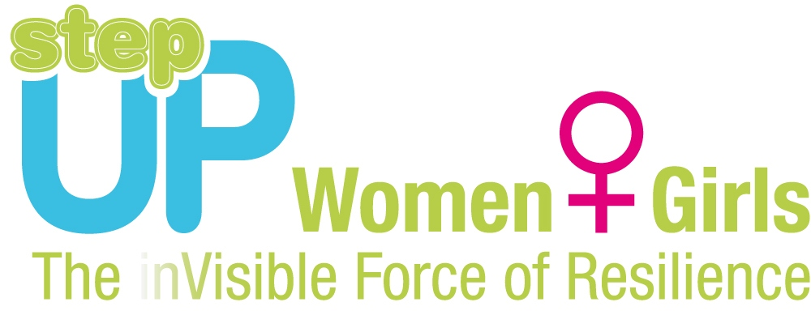

Marking the International Day for Disaster Reduction
Europe House Georgia, 1 Freedom Square

12 October 2012

AGENDA

14:00-14:05 Event opening
Ketevan Lomsadze, Program Officer, European Commission Humanitarian Aid and Civil Protection (ECHO)

14:05-15:00 Interactive presentations by the DIPECHO partners

14:05-14:20 Save the Children / Arbeiter Samariter Bund
A puppet show and performance by the kindergarten children

14:20-14:30 Oxfam / Black Sea Eco Academy
Simulation activities by the village emergency groups from the Ajara region

14:30-14:40 Danish Red Cross (DRC) together with Georgian Red Cross Society (GRCS)
Presentation of a new psychosocial game

14:40-14:50 Action Contre la Faim (ACF)
Sharing of experiences by female teachers from the Svaneti region

14:50-15:00 UNICEF

Presentations of paintings and essays by the students from the DIPECHO pilot schools on environmental protection and disaster risk reduction activities at the community level

15:00-15:10 Award ceremony

15:10-15:25 Questions and answers

15:25-15:30 Final remarks and event closing
Ketevan Lomsadze, Program Officer, ECHO

15:30-16:00 Coffee and refreshments

Side events:
- Exhibition of children’s artwork on climate change adaptation and disaster risk reduction
- Display of the DRR publications and other visual materials developed by the DIPECHO partners

