Delhi Preparing for Disasters
AIDMI invited by Delhi Disaster Management Authority (DDMA) and National Disaster Management Authority (NDMA) to facilitate education track organised under Delhi Emergency Management Exercise (DEMEx) from November 29, 2012 to December 5, 2012. This is fifth EMEx in India. Dr. (Shree) Muzaffar Ahmed, Member, NDMA, India highlighted the important role of educator to build the capacity of youth and children in India during first day of school safety training. The following session were emphasised during the trainings based on the need and expectations of the participants.
Dr. (Smt) Kiran Walia with teachers during closing ceremony of Preparatory Workshop on School Safety. Organised by DDMA and NDMA at Delhi Secretariate, November 22, 2012. AIDMI shared the learning from school safety audit with group
- Concept of Disaster Risk Reduction
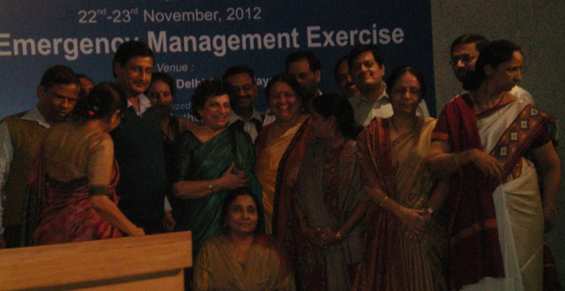
- Safety Audit of Educational Institutions
- Preparing Disaster Management Plan for Education Institutions
- Practical activities to build DRR education
- Role of different stakeholders
The motive behind such drills is to make people and the resident welfare associations aware of things that should be taken care of in case of any disaster. Through these drills, we can make our emergency response services better,’ said by Shree Kuldeep Singh Gangar, Special Secretary, DDMA. The emergency management exercises are especially important as vulnerability of large cities to disasters is increasing due to unplanned urbanisation resulting in environmental degradation (e.g. deforestation), over-exploitation of natural resources (e.g. water), ecological disturbances (e.g. pollution), and social destitution (e.g. increase in poverty). Increased population concentrations and poor construction further increase the vulnerability of built environment and the fragility of socio-economic systems. At the same time, economic growth and the resulting social changes have exposed them to various kinds of technological and fire hazards. Moreover, climate change has also increased the frequency and intensity of natural hazards. In order to make disaster resilient cities, it is important to adopt an integrated approach that takes into account multiple hazards and vulnerabilities for comprehensive assessment, mitigation and preparedness and integrate disaster risk reduction into sustainable urban development goals. Cities and local governments need to get ready, reduce the risks and become resilient to disasters. To strengthen cities’ readiness against floods and other natural hazards, UNISDR running campaign on ‘The Making Cities Resilient campaign’ since May 2010. The campaign is to raise awareness and urge mayors and local governments to invest more in disaster risk reduction. The campaign addresses issues of local governance and urban risk while drawing upon previous UNISDR Campaigns on safer schools and hospitals, as well as on the sustainable urbanizations principles developed in the UN-Habitat World Urban Campaign 2009-2013.Recently UNISDR launch report on ‘Making Cities Resilient Report 2012’. This report provides a snapshot of resilience building activities at the local level and identifies trends in the perceptions and approaches of local governments toward disaster risk reduction.
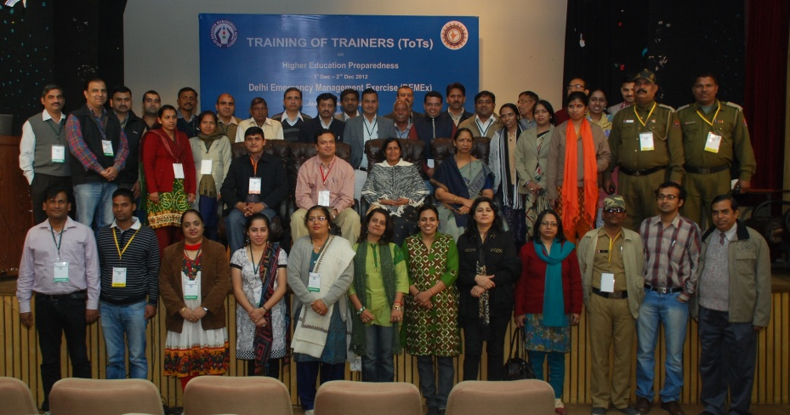
41 participants from different higher education institutions of Delhi participated in training on Disaster Risk Reduction in Higher Education at Delhi on December 1 – 2, 2012. Organised by DDMA and NDMA India and facilitated by AIDMI.

Since the year 2001, AIDMI has worked at least in 37 cities from 11 states/ Union Territories of India. AIDMI is documenting the learning based on the experience of facilitation of education track of five EMEx. For more information, contact Mr. Sanchit Oza, bestteam@aidmi.org.

