IDRC, Workshop on National Platforms, 23-29 August 2009

Action Plan for the establishment of a National Platform in Bangladesh

Authors: Prof. Jamilur Reza Choudhury (Vice-Chancellor BRAC University) and Giacomo Solari (SDC) with inputs by Barbara Rothenberger (SDC)

Version 1.0 Date: 29 August 2008
Version 1.1 Updated (JRC) Date: 25 September, 2008

[Working document to be validated and revised in the future discussions among the parties]

General institutional and political context

…

Structure of the National Disaster Management System according to Standing Order on Disasters of 1998:

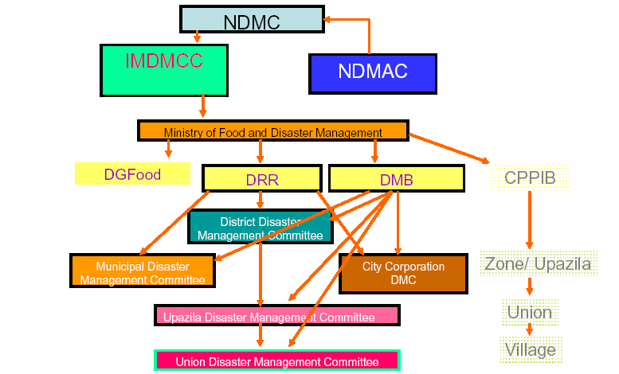
Action Plan:
HFA  AP | Action line  Objective with short description | How is it done?  Activity | Who does it? Responsible or partner institution (NDMAC advisory function) | Estimated Budget and Who pays for it? | Time Framework | Remarks  Assumptions/Threats/ Opportunities
1. Recommendations to strengthen the coordination of DRR in Bangladesh
1.1 | The Standing Orders on Disasters (1998) envisages formation of “The National Disaster Management Advisory Committee” (NDMAC) – this is has not been created. NDMAC should be created after the elections of December 2008 | NDMAC is included in the draft Disaster Management Act  Alternatively create it by ordnance of the present government to be confirmed by the first session of the elected Parliament | Parliament | Tbd (should include awareness building activities, capacity building, including participation at important regional and international conferences, consultancy fees and studies | First trimester 2009 at latest | Political and institutional will to create an advisory board that include other stakeholders than the State  The NDMAC has an advisory function but no operational function.  It ensures the participation of all the relevant sectors of society across the different areas and expertise
1.2 | The NDMAC is proposed as the National Platform for DRR for Bangladesh | Official communication to the ISDR Secretariat | Elected or present government |  |  | Political will to create a NP
1.3 | The Focal Point for the HFA is designated | Official communication to the ISDR Secretariat | Present government
1.4 | CDMP II supports the creation of the NDMAC and its work |  | UNDP  CDMP partners |  | CDMP presently under revision | CDMP II should reduce overlapping and management capacity should be improved.  Establish, down to the Upazila level, disaster management office; fully functional all the year round; under DMB;  Enough resources are available for CDMP II  The CDMP is one of the main channels for support
1.5. | Revise (if necessary) and adopt the Draft national Disaster Management Act (presently system is based on the 1998 Standing Order) | … | DMB and partners  Parliament |  | After elections | Likelihood that Act is going to be adopted
1.6 | Propose amendments (if necessary) to Draft National Plan of DM  (NDMAC in charge of reviewing Mid Term Review) |  | DMB and partners  NDMAC (after establishment) |  |  | Likelihood that Plan is going to be adopted
1.7 | The ranking of the Director General of DMB should be increased from joint to additional secretary |  | CDMP partners  NDMAC as soon as established |  |  | DG DRR can remain joint secretary because more an executive function)
1.8 | Network of Disaster Risk Reduction focal points coordinated by DMB | Designate focal point for DRR in each ministry or relevant divisions / capacity building activities/ champions of DRR. Regular meetings organized by DMB | Decision by the Government (could be introduced in the Act?)
2. Composition, functioning and role of the NDMAC
2.1. | Revise the composition of NDMAC considering the stakeholders that are missing (see following sub-items) | Number of participants should no exceed 40, identify criteria provide criteria to identify the composition of the governmental body, define the relation with the IMDMCC / NDMAC/ Introduce criteria of rotation |  |  |  | Designated persons have the time + willingness to attend regularly at the meetings without sending replacements  Resistance to establishment of an advisory board
2.1.1 | Deputy-chair of NDMAC should be the Secretary of the Ministry for FDM while the Secretariat should be ensured by DMB |  |  |  |  | This will increase the ownership of MFDM and ensure a proper link with the IMDMCC (whose chair is the Minister of MFDM)
2.1.2 | To be included in the NDMAC : - Chairperson of local governments (city corporations, municipalities and Upazilas) | To be nominated by Ministry of local government, rural development and cooperatives
2.1.3 | - Head of the Climate Change Cell
2.1.4 | - Chairperson of National Federation of Women
2.1.5 | - National Council for Indigenous People/ Ethnic Minorities/”Adibashis”
2.2 | Define subcommittees (permanent or ad hoc). They could include the participation of specific stakeholders that are not included in NDMAC | (e.g. more professional organizations in the sub committee dealing with private-public partnerships)
2.3 | Number of meetings: at least 4 time p/year + additional if necessary  Subcommittees: can be more frequent
2.4 | Define reimbursement of costs + honorary for NDMAC and Sub-commissions members | (e.g. ~4000 Taka per session)
2.5 | Ensure that the members of NDMAC and its Subcommittees have the right skills and capacity by providing capacity building | Briefing and training including some exchange travels + video-conferencing | DMB in collaboration with CDMP.  PPDM, BRAC University could be the provider of training and other capacity building activities; |  |  | Assuming CDMP is continuing, otherwise look at other international support for DRR, including, bilateral, UNDP, GFDRR, etc
2.6 | Precise the role and function of the NDMAC (at the moment is very broad) | Suggestion: to add in the present formulation of the Standing Order: “…all aspects of DRR including technical management…”  Take list of activities proposed by ISDR Guidelines on NP as an example (p. 10) |  |  |  | Broad definition of roles can be useful and more flexible
3. Recommendations for some priority lines of action to be contemplated by the work plan of the NDMAC
[The following proposals needs to be checked against already defined priorities in the Draft National Plan for DM]
3.1 | Baseline information on DRR
3.1.1 | Review Assessment reports of the Disaster Management Information Network (DMIN) and propose new information that might be lacking (e.g. climate change, social + economic vulnerability, etc) | Be sure that assessment reports are in a form that could be broadly disseminated | With DMB,  CDMP |  |  | DMIN is established and functioning 2008
3.1.2 | Review Multi-hazard maps (esp. flooding, cyclones and storms and earthquake) are established/updated at Upazilas and Unions levels | Establish one sub-committee established in charge of reviewing Upazilas risks maps taking in consideration new criteria if needed, Establish ranking of Upazilas and Unions at risk | DMB, CDMP (NDMAC review function)
3.1.3 | Earthquakes Hazards and Vulnerability assessments, esp. building (survey) in Dhaka, Chittagong, Sylhet Cities | Extend the Studies (Microzonation) to other cities and towns in zone 2 and 3
3.2 | Search & Rescue system
3.2.1 | Equipment and training (including maintenance) for Fire Brigades and Civil Defence |  | DMB  CDMP |  |  | Low priority for the government: at least ¾ of resources lacking  Fire Brigades and Civil Defence need to be strengthened  Consider also role of Army (responsible for contingency plan in case of big earthquake in Dhaka)
3.2.2 | Train community volunteers equipment in Dhaka city | Neighbourhood programme | DMB  CDMP  Bilateral cooperation
3.3 | Improve community preparedness for floods, cyclones and storms (country side along the delta) | More regular training of community volunteers and financial incentives taking into consideration the participation of women and girls | DMB  BDRCS / IFRC  CDMP
3.4 | Early warning for cyclones and storms | Improve public awareness and technical means; Awareness raising among school children and adults using the audio-visual media…particularly for the less privileged group of the society who don’t have much access to this media  Consider specifically the situation of fishermen |  |  |  | Fishers are often sent to catch bigger amount of fish (when low pressure/storm approach) without mobile telephones to avoid their return / higher number of death in comparison to other groups
3.5 | Building codes and retrofitting of constructions
3.5.1 | Building codes enforcement for earthquake | Update regulation, ensure enforcement through training | DMB  CDMP |  |  | Retrofitting only increase 3-4% the cost of building
3.5.2 | Introduce hazard resisting housing (especially cyclone, storms and floods) in the rural areas | Improve non-engineering constructions
3.6 | Develop a national plan for capacity building for DRR | Survey on existing capacities at national level and initiate a national programme for capacity building | National and foreign Universities (partnerships)  UNDP  CADRI |  |  | At the moment there is only one postgraduate/masters programme on Disaster Management at BRAC University with annual output of 25 graduates
3.7 | Revise 1993 Masterplan for Multipurpose Cyclone Shelters ( for population and livestock in High Risk Areas) | Revise plan + update taking into account new techniques (geo-textile for steeper land with less land needed) and new risks (e.g. climate change) | CDMP  Bilateral cooperation |  |  | 1993 Plan only partially implemented (about 50%)  People reluctant to use shelter if livestock (including animals) not included
3.8 | Enhancing natural barriers through eco-engineering and reforestation schemes (in combination with artificial floods embankments) | Introduce performing species adapted to specific regions and that provide additional ecosystem services;  Plant newly established islands (by planes) | Bilateral agencies and NGO  UNEP  UNDP |  |  | Strong embankment techniques (very expensive) only in critical areas like Chittagong (industries)  Sea level rise  For the moment not yet observed  But is expected to reach 50 cm by 2050 (optimistic prevision?)  Coconuts trees very performing and provide water in case of disasters
3.9 | Define Land ownership on newly formed islands to avoid unsafe behaviours | Study carried out to assess the problem |  |  |  | Occupants of newly established islands are reluctant to evacuate
3.10 | Better coordination of DRR and CC Adaptation |  | CDMP  Relevant ministries
3.10.1 | Increase synergies with CC Cell and Ministry of the Environment for better coordinating DRR and CC strategies | Support recommendation  5.2.1.1 from the NPDM (p.92) and advocate for its implementation
3.10.2 | Ensure that revised NAPA and establishes correct linkages with Disaster Management System
3.11 | Promote Public Private Partnerships and Risk Transfer | Also promote the concept of risk reduction /response & recovery/awareness raising through corporate social responsibilities
3.11.1 | Set-up an Insurance scheme for the government in case of disaster |  | Ministry of Finance  GFDRR  ADB  Swiss or Munich Re
3.11.2 | Explore micro-finance and micro-insurance schemes for DRR for the most vulnerable |  | tbd
3.11.3 | Set up PPP with the Bangladesh Garments Manufacturers and Exporters Association (BGMA) for earthquake and wind safe buildings | Ensure retrofitting of houses | GTZ  BGMEA  CDMP | 50% cooperation  50% BGMEA |  | Relatively weak private sector in Bangladesh  employing 2.1 Mio Women (must fulfil compliance standards, of which one is safety of workplace)

