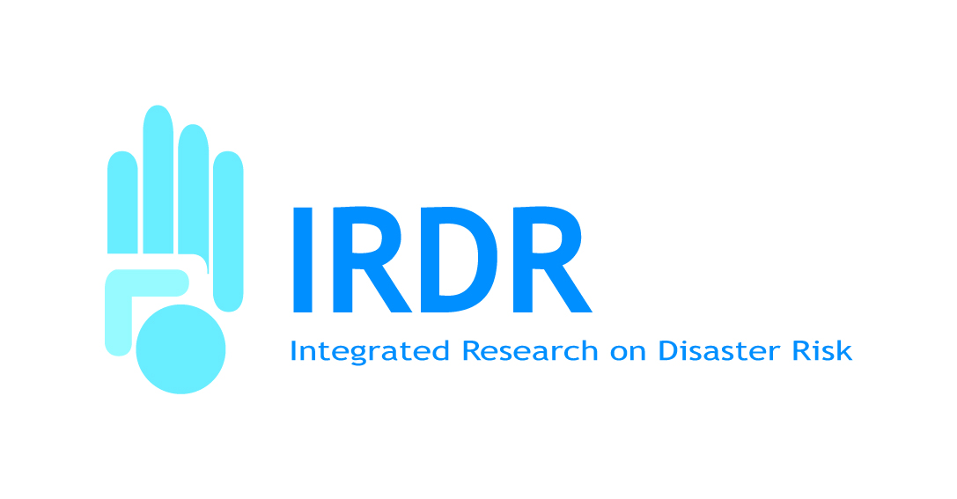Announcement

Executive Director of the

Integrated Research on Disaster Risk (IRDR) programme

Beijing, China

The International Council for Science (ICSU), the International Social Science Council (ISSC) and the UN International Strategy for Disaster Reduction (UN-ISDR) invite applications for the post of Executive Director of the Integrated Research on Disaster Risk (IRDR) programme, which will be vacant on 01 June 2016.

IRDR is an international research programme addressing all hazards bringing together the natural, social, medical and engineering sciences. Its objectives are the scientific characterization of natural and human-induced environmental hazards, vulnerability and risk; the understanding of decision-making in complex and changing risk contexts; and the reduction of risk and curbing losses through knowledge-based actions. The programme is founded on the recognition that disaster prevention and mitigation are critical dimensions of the global poverty reduction agenda and efforts to adapt to climate change, and should be an integral part of all international and national development efforts.

The Executive Director heads the IRDR global programme and is supported by a small International Programme Office (IPO) being hosted by the Institute of Remote Sensing and Digital Earth (RADI) of the Chinese Academy of Sciences in Beijing, China, with core funding from the China Association for Science and Technology (CAST). RADI is a major research institute with wide experience and expertise in remote sensing, data collection and modelling, located on the edge of Beijing. The Executive Director will be a full-time employee of RADI.

The IPO meets the management needs of the IRDR programme, supporting the work of the international Scientific Committee responsible for the overall scientific planning, as well as IRDR’s growing network of national committees, regional committees and international centres of excellence around the world.

The Executive Director of IRDR is expected to:
- Lead on the elaboration and implementation of a strategy and workplan in close collaboration with the co-sponsors and the Scientific Committee;
- Facilitate the development, implementation and co-ordination of IRDR science projects, policy projects and those carried out jointly with partner programmes;
- Lead on the development and implementation of a communications and outreach strategy;
- Actively engage with the IRDR community (international centres of excellence, national committees, etc.) and stakeholders in China, across the region, and globally (including the international policy community and funding agencies);
- Promote the establishment and/or strengthening of national IRDR committees and regional initiatives, with an emphasis on improving the science/policy interface;
- Lead on fundraising for the programme; and
- Ensure effective representation and links between IRDR and other relevant international research programmes and their sponsoring organizations, including Future Earth.

The Executive Director reports to the three co-sponsors of IRDR, particularly on important or strategic issues and the overall development of the programme; maintains excellent communication and collaboration with the Scientific Committee on all scientific issues; effective cooperation with the donor and host institutions in Beijing, especially on administrative and technical matters and possibly on joint programmatic initiatives; and develops/maintains relations with other key relevant local organizations.

The Executive Director manages a team of typically four staff members and directs all activities of the IPO. Much of the activities of the IPO revolve around a cycle of designing and fundraising for initiatives designed to build the IRDR network and research, often implemented through a mix of meetings, travel and virtual communications. The work includes assisting preparation for meetings of the Scientific Committee, National / Regional Committees and International Centres of Excellence or others involved in programme initiatives. He/she will have responsibility for drawing up annual workplans and budgets for the Office, and ensuring that they are implemented.

The IRDR programme is currently going through a mid-term review by the three co-sponsors which is looking at scientific achievements, management and operations, and will be providing recommendations on future directions.

The Executive Director will hold a PhD in a natural, social, medical or engineering science discipline related to natural hazards and disaster risk reduction and have several years of direct experience in international programme management. Proven management, fundraising, and diplomatic skills, and capacity to work in a multi-cultural environment will be essential. Both an excellent command of written and spoken English and a working knowledge of Mandarin are required. The following additional qualities are considered to be essential:
- The ability to lead and motivate a small team; operating in a complex area
- A high level of flexibility and adaptability
- The ability to think strategically while managing the operational side of the programme, including host reporting requirements
- An understanding of Asian and other cultures.

Applications should include: (i) a Curriculum Vitae; (ii) a covering letter explaining why you are interested in the post, and outlining the skills and experience you feel you, the candidate, could bring to IRDR and its IPO; and (iii) the names and addresses of three individuals who have indicated their readiness to provide a reference.

Applications combined into a single PDF file should be sent to the International Council for Science (ICSU) via e-mail to recruitment@icsu.org, with “IRDR Executive Director” in the subject line.

The closing date for applications is 18 March 2016 midnight Paris time (CET).

The salary of the Executive Director of IRDR will be negotiable but UN salary scales do not apply for this post. The initial contract of employment will be of two years’ duration, renewable. It is expected that the successful candidate would take up his/her appointment, located in Beijing, on 1 June 2016.

For more information on the IRDR visit the programme’s website at: http://www.irdrinternational.org/

