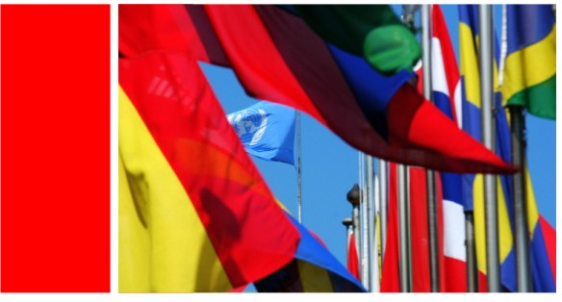

UNISDR Consultative Meeting with Parliamentarians in Africa
Making Disaster Risk Reduction a Tool for Climate Change Adaptation
Nairobi, Kenya 19-20 February 2009

General Information

Introduction
“The UN should take a series of steps to enhance links and ensure synergy between disaster risk reduction and the climate change agenda” said the Secretary General, Mr. Ban Ki-Moon in his decision 2007/19 in April 2007.

Recognizing that parliamentarians have an important role to play in securing political commitment, influencing policy change and developing a legal framework for disaster risk reduction, climate change mitigation and reduction, this Consultative Round-Table aims to contribute to the ongoing effort in enhancing the link between disaster risk reduction and climate change adaptation.

Context
Climate change, rapid urbanization and environmental degradation are making disasters more frequent and devastating than ever before. Serious damage and loss of life caused by climate –related disasters such as storm, flood, and drought are reported on regular basis. Disasters are increasingly threatening basic human security, sustainable development and poverty reduction goals worldwide.

The data available shows that the African continent has, over the years, experienced increased frequency and impact of climate-related disasters, including floods, cyclones and devastating droughts, which are an ever growing threat to the livelihoods of millions of people across Africa. The impact of climate change on Africa is real and the socio-economic impact of climate change will be getting worst on a large-scale.

Scientific studies available show that climate change has various impacts on Africa, but that agriculture is particularly vulnerable to climate change. Even with perfect adaptation, regional climate change is predicted to result in production losses of 18.9 percent for Burkina Faso and 30,5 percent for Niger. In Ethiopia and Kenya respectively, children aged five and under are 36-50 percent more likely to be malnourished. The Human Development Report of UNDP underlined the African’s vulnerability to the impact of climate change. Crops fail, people go hungry, and women and young girls spend more hours collecting water. Clearly, immediate actions need to be taken to reduce the impact on climate-related drought, floods and cyclones in Africa.

To curb the growing impact of disasters on people and socio-economic development, more than 160 government delegations came together at the World Conference on Disaster Reduction in January 2005, Kobe, Japan, where they collectively endorsed the Hyogo Framework for Action (HFA) 2005-2015. Its overarching goal is to build the resilience of nations and communities to disasters. Although more than 120 countries have designated official Focal Points for the implementation of the Hyogo Framework, progress in the last three years has proved very slow.

The slow progress in reducing disaster risks is not only due to competing priorities, but also due to low understanding of the ability of disaster risk reduction for reducing climate impact and achieving sustainable development. According to the World Bank and the Asian Development Bank, one dollar in disaster risk reduction can save 4-7 dollars in disaster response and recovery. Mozambique’s success in early warning and preparedness in 2007 has shown in Africa that investment in risk reduction protects lives and livelihoods.

Disaster risk reduction is still on the margins of the government development agenda even though it represents a vast amount of preventive savings in lives and livelihoods. Disaster risk reduction has not been used as a tool for immediate climate change adaptation. Risk assessment has not become an integral part of development planning and practice in most countries. Resources are often not available to take concrete or widespread action to reduce disaster risks and vulnerability.

There is an urgent need for political leaders and legislators to commit to creating an enabling environment for disaster risk reduction at a national and international level. The recent consultative meeting of parliamentarian meetings in Manila called for development of an international legal framework for disaster risk reduction, among other actions. The World Bank meetings of parliamentarians on climate change and disaster risk reduction underlined the needs to shift from a reactionary to a preventive approach to disaster management. The meeting emphasized that parliamentarians have the responsibility to advocate for proactive and preventive strategies to decrease vulnerability to disaster and climate change, with particular attention to the poor and women. Disaster risk reduction should be a national and community priority - it is the first line of defence against climate change.

Clearly, the world needs policy change in socioeconomic development thinking, planning and practice in order to disaster-proof and climate change-proof people’s livelihoods and national economic growth. 2007 has seen increased understanding among parliamentarians of their crucial role in making disaster risk reduction a national priority, and making their constituents disaster proof. More and more politicians and legislators from different continents have showed growing interest in disaster risk reduction and climate change adaptation.

It is vitally important to extend the dialogue to Africa, most vulnerable to the impact of climate-related disasters. The Government of Kenya and the UNISDR will co-organize a consultative roundtable meeting on making disaster risk reduction a tool for climate change adaptation, similar to that organized in Manila in October 2008. The roundtable consultation will focus on the roles of parliamentarians in two areas: 1) disaster risk reduction as a tool for climate change adaptation, and 2) how reducing disaster vulnerability and risk can be mainstreamed into socioeconomic development.

Objectives
The overall goal is to make disaster risk reduction a national and community priority, in order to increase national and community resilience to disasters and impact of climate change. The specific objectives of the Consultative Meeting of Parliamentarians are threefold:
- Update participants on global trends and progress in disaster risk reduction and its mainstreaming in socio-economic development
- Review available ways and means to achieve synergy in addressing climate change adaptation and disaster risk reduction.
- Discuss the ways forward for creating a more enabling environment for political commitment and financial investment in reducing disaster vulnerability and risk in the context of socio-economic development.

Expected Outcomes
The expected results of this consultative meeting will include:
- Increased understanding of disaster risk reduction and its linkage with climate change adaptation
- Areas identified where disaster risk reduction can be used as a tool to support climate change adaptation initiatives
- Concrete steps identified and agreed upon, to promote more political commitment and financial investment in reducing risks and vulnerabilities related to disasters and climate change.

Date
The Consultative Meeting will be held 19-20 February 2009 in Nairobi, Kenya
Language: The proceedings will take place in English only.

The impact of climate change on Africa agriculture: a ricardian approach (2007)
Human Development Report 2007

